ASSESSMENT 3 - TEST CASES

HOW WILL YOU GET MARKED?
You need to create 10 testcases by using the following template:

Test Case ID | Software Feature | Steps | Expected | Actual Result | Passed/Failed

You will get 1 point per successful test case. However, both quality of the test instructions (steps and expected columns) and the actual result will affect your final mark. For example:
- Assume your program passed all the tests and you provided the screen shots of the result screen, you still won't get 10 if your test cases have poor designed steps and/or are without sufficient instructions, e.g.:
  - bad instruction: enter your admin name.
  - good instruction: enter "Arthur" in the text prompt "Please enter your username:".
- If you have not implemented the relevant feature, you will be able to get a partial mark for a test case as long as your testcase contains well designed steps and meaningful instructions, e.g.:
  - You can have a testcase for GUI with UI mock-ups in the expected column.
- Incomplete test will not be marked, e.g.:
  - A test with insufficient instructions and contains not results.

EXAMPLE: TESTCASE 0: SUCCESSFUL USER LOG IN.
- Highlight either Passed/Failed as the outcome.
- For the actual result column, screenshots must be included.

Test Case ID | Software Feature | Steps | Expected | Actual Result | Passed/Failed
0 | Successful user log in | 1. Run  Programme  2. Enter: David  3. Enter: aBC | Banking system app  Starts successfully,  and it asks for a username.  Username  taken and the  programme  will ask for a  password.  Login successful and the user menu will be displayed.  Login successful and the user menu will be displayed. | 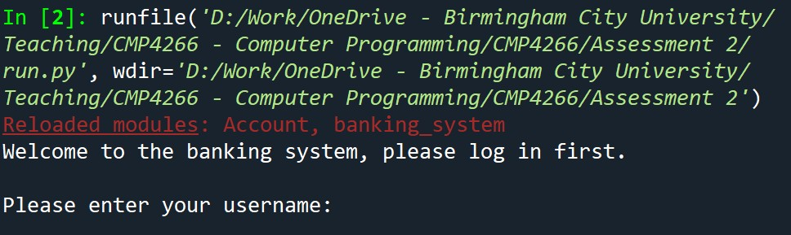  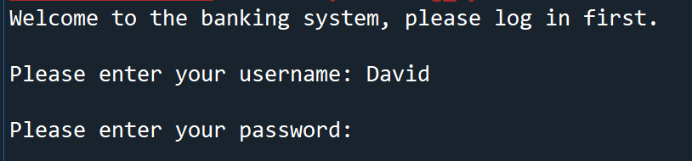  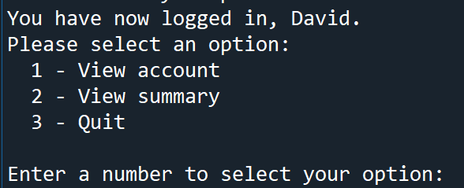 | Passed
1 | Successful user log in | 1. Run  Programme  2. Enter: admin  3. Enter: 123 | Hospital system app  Starts successfully,  and it asks for a username.  Username  taken and the  programme  will ask for a  password.  Login successful and the user menu will be displayed. | 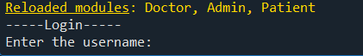  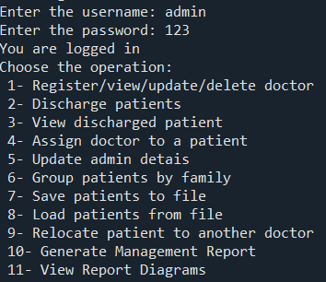 | Passed
2 | Register Doctor (Op 1) | 1. Choose option '1' from the main menu  2. Choose option '1' from the Doctor Management.  3. Enter "Vika" for first name.  4. Enter "Green" for surname.  5. Enter "Surgery" for speciality. | The system confirms registration and it adds this doctor to the list where other doctors are. If you then choose option '1' and option ‘2’ which is ‘View’ , "Vika Green" appears in the doctor list. | 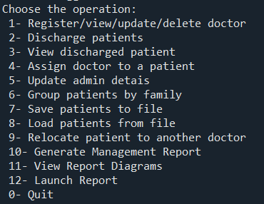  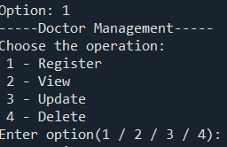  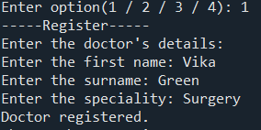  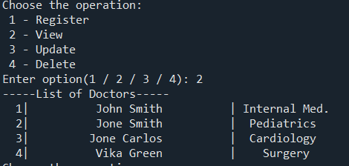 | Passed
3 | Discharge (View) Patients (Op 2) | 1. Choose option '2' from the main menu.  2. to discharge a patient need to enter ‘y’ – yes on a question.  3. | After you enter ‘y’ to discharge a patient, it will ask you about its ID. Then that patient is removed from the active list. Choosing option '2' again shows they are no longer in the system or option ‘3’ that will show discharged patient | 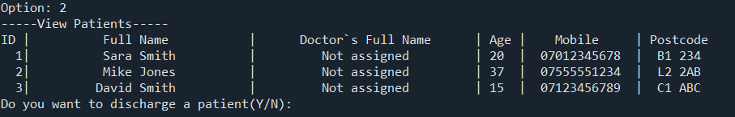  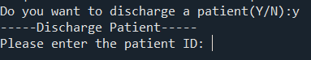  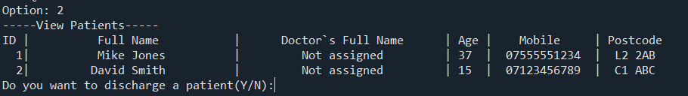  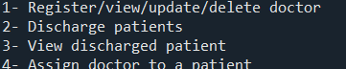  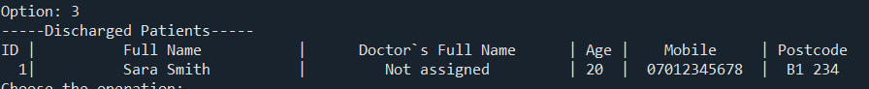 | Passed
4 | Update Doctor (Op 1) | 1. Choose option '1' from the main menu  2. Choose option '3' from the Doctor Management.  3. Enter ID of a doctor that you want to update.  4. Enter 1 for option first name.  5. Enter "Sam" for update first name. | The doctor's first name is updated to "Sam". The change is shown when viewing the doctor list (Op 1 -> Op 2). | 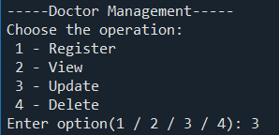  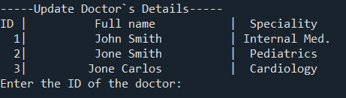  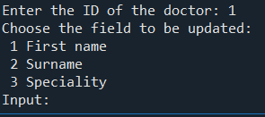  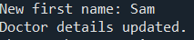  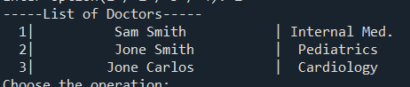 | Passed
5 | Delete doctor (Op 1) | 1. Choose option '1' from the main menu  2. Choose option '4' from the Doctor Management.  3. Enter ID of a doctor that you want to delete. | The doctor is removed from the system. They no longer appear in the doctor list or the workload report. | 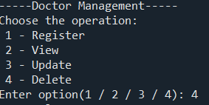  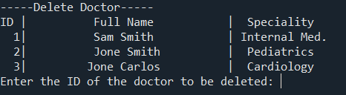  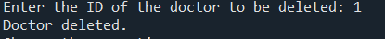  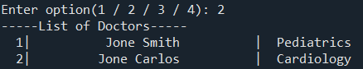 | Passed
6 | Assign doctor to a patient (Op 4) | 1. Choose option '4' from the main menu  2. Enter the patient ID that you want to assign  3. Enter the doctor ID that you want to assign | The system links the patient to the doctor. The patient's record now displays the assigned doctor's name. | 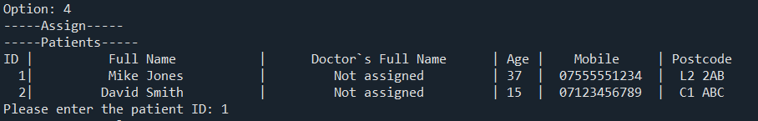  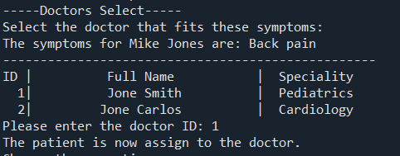 | Passed
7 | Group patients by family (Op 6) | 1. Choose option '6' from the main menu | The system displays patients grouped by their surname, showing family units based on matching last names. | 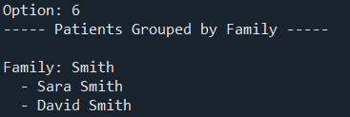 | Passed
8 | Generate Management Report (Op 10) | 1. Choose option '10' from the main menu | The system prints a summary including total doctors, patients per doctor, April appointments, and illness type totals. | 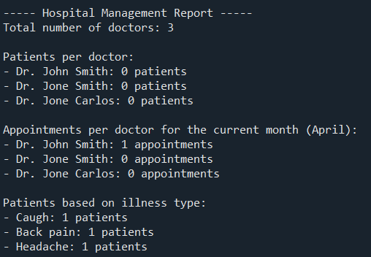 | Passed
9 | Launch Report (Op 12) | 1. Choose option '12' from the main menu | It opens a GUI designed report where it displays all functions and data that has been used into system | 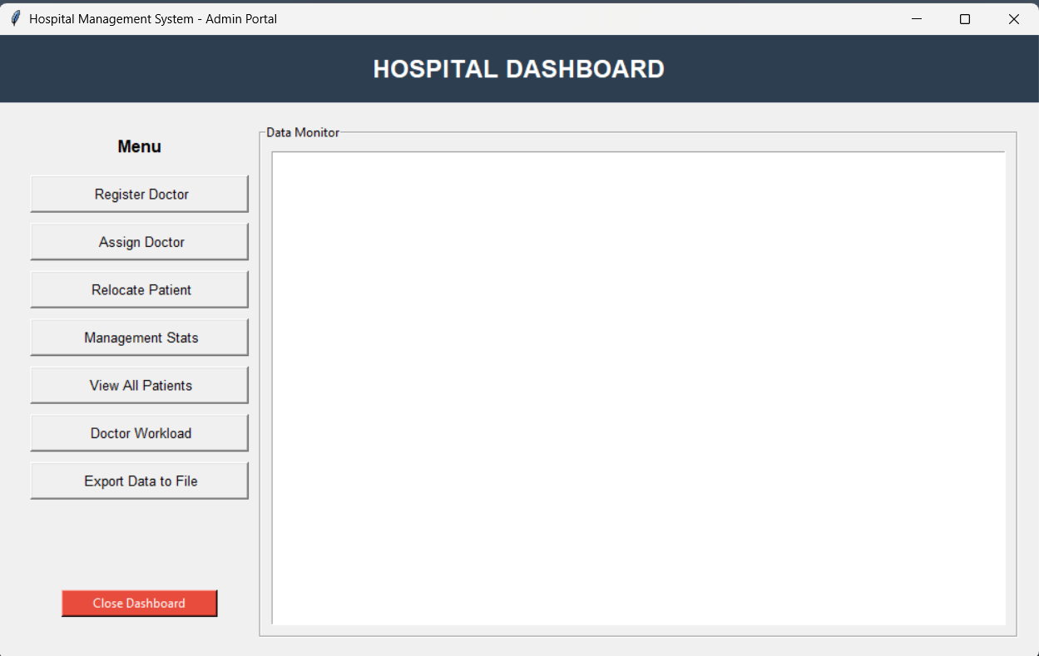 | Passed
10 | Quit the system (Op 10) | 1. Choose option '0' from the main menu | It logs the user out and it closes the system | 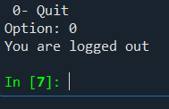 | Passed

